# **Restaurants in Lisbon**

### Problem

What would be the best place to open up a restaurant?

### Introduction

This can be a very difficult question, since it may depend on so many factors:

* popularity of each cuisine;
* county;
* geographic location (to know the best cuisine type);
* tourism;
* rent prices;
* etc.

In this study, will only be considered the population, potential competition, variety of cuisines and number of restaurants for each county.

### Important notes

The majority of the data will lay on the Foursquare API, which may not be updated or 100% correct.

Lourinhã was excluded from this work as there was 0 registers of restaurants there.

### Who would be interested in this

Any person who wants to start a new restaurant business in Lisbon and has no idea on how to choose a place, in order to get popularity, clients, etc, could be potentially interested in this study.

### Methodology

In this work, the main objective is to explore all the previous refered factors and cluster counties based on their most common restaurants.

With all the exploration and results we will be able to compare what would be the best place to open up a restaurant, depending on the situation, as there is no linear answer for that.

**Data source:**

* Foursquare API – to get the most common venues;

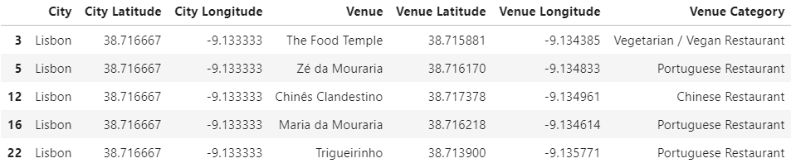

* [**https://simplemaps.com/data/pt-cities**](https://simplemaps.com/data/pt-cities) - latitude and longitude values for each county in Portugal;

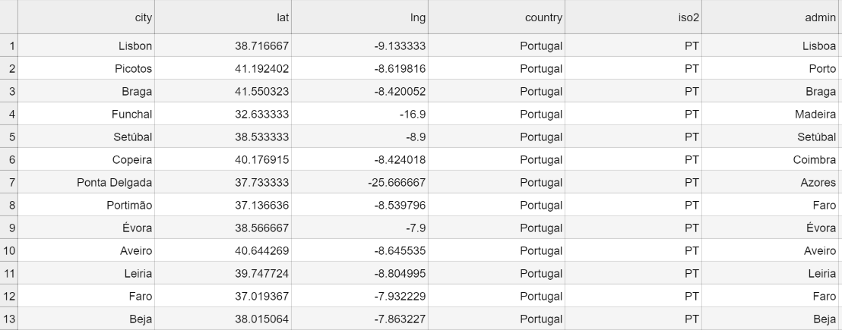

* [**https://pt.wikipedia.org/wiki/Lista_de_munic%C3%ADpios_de_Portugal_por_popula%C3%A7%C3%A3o**](https://pt.wikipedia.org/wiki/Lista_de_munic%C3%ADpios_de_Portugal_por_popula%C3%A7%C3%A3o) – Population per county (2018).

This was cleaned by me with the only wanted values – population for each county of Lisbon.

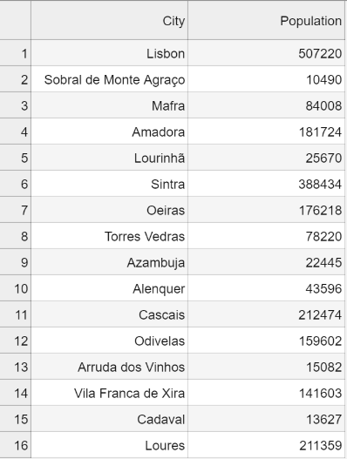

#### Counties of Lisbon

The dataset was cleaned into a new one, containing only the counties of Lisbon and their latitude and longitude values. With that information, a map was drawn, marking each county.

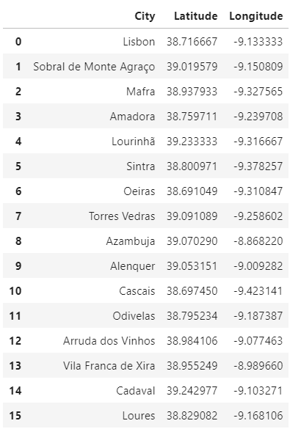

With the Foursquare credentials, a call was made to the venues/explore endpoint, in order to get the most common venues for each county within a 500 meter radius.

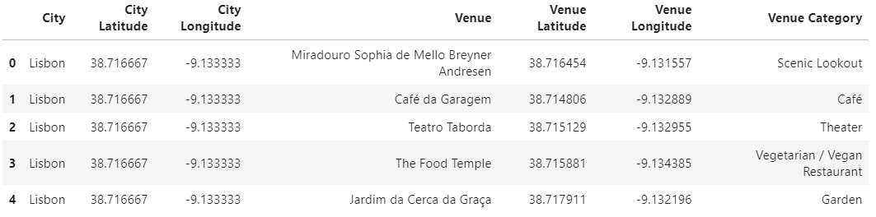

The *Restaurant* venue category is completely irrelevant as does not specify any kind of cuisine, so it was removed from the dataset.

#### Most common cuisines

After that, a new dataset was created with the dummy values (one hot encoding) of the previous dataframe.

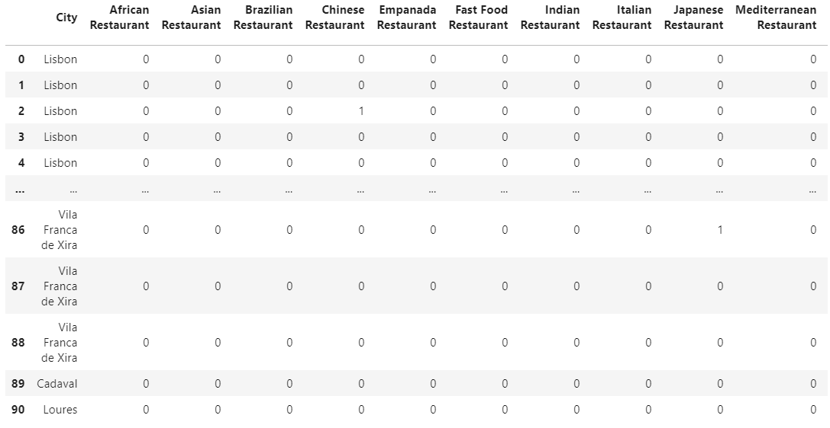

Also, the mean values of the duummy dataset:

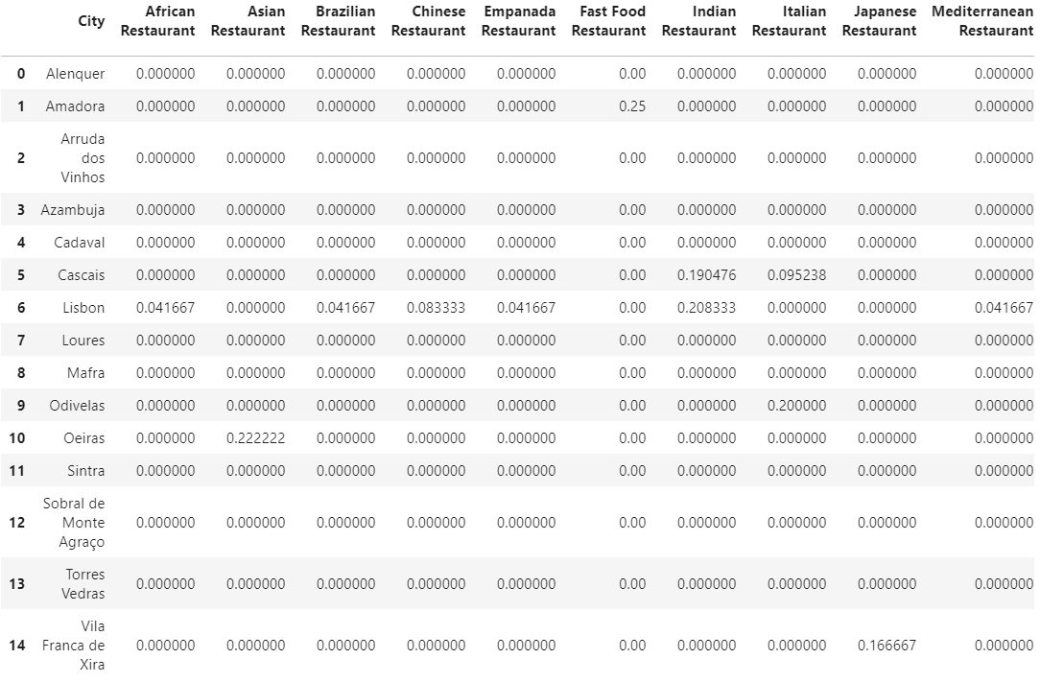

This dataframe will be useful to visualize the most common restaurants for each county.

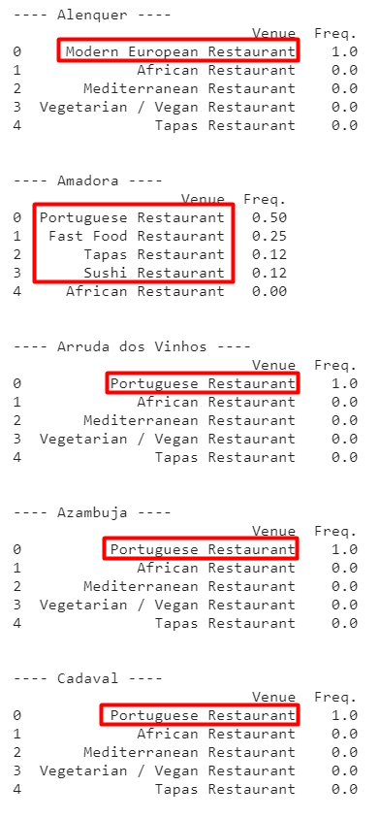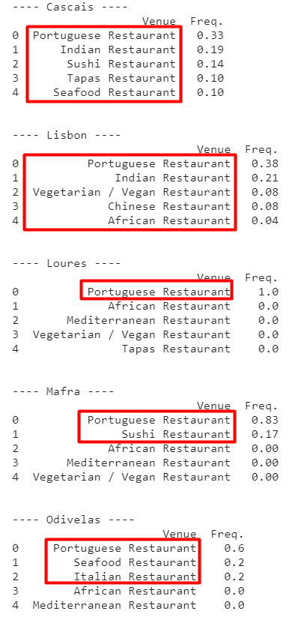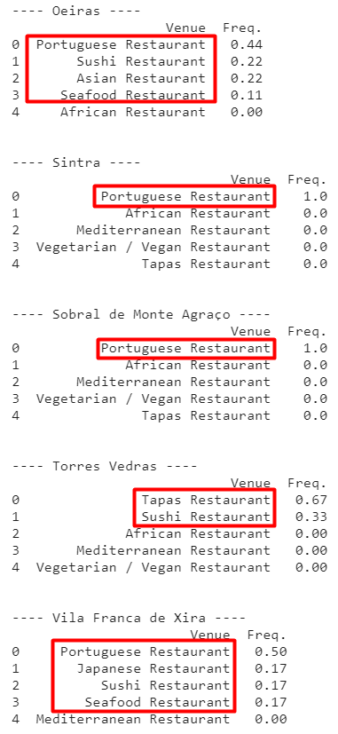

We can also visualize the most common cuisines, with the mean of the mean dataset. The portuguese cuisine is the most common of all and the African is the least common.

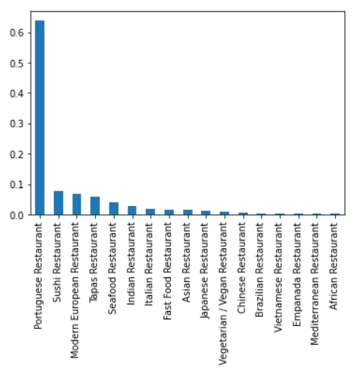

#### Cuisine variety for each county

And the cuisine variety for each county. Lisbon and Cascais have the most variety and the portuguese cuisine appears in the majority of almost every county.

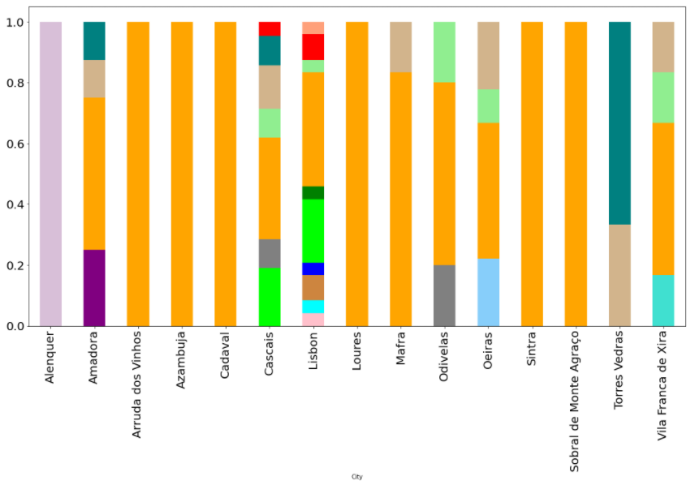

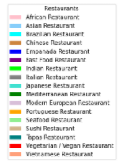

The population and the number of restaurants of each county were plotted. With both these plots we manage to see if there is any lack or excess of restaurants for each county, according with their population.

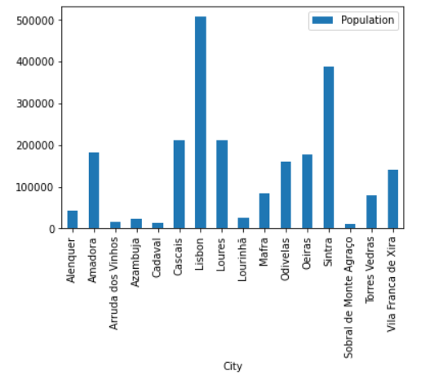 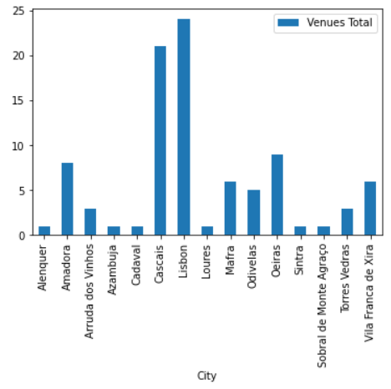

The population was divided by the number of restaurants. Sintra and Loures have the biggest lack of restaurants and Arruda dos Vinhos and Cascais have the most number of restaurants.

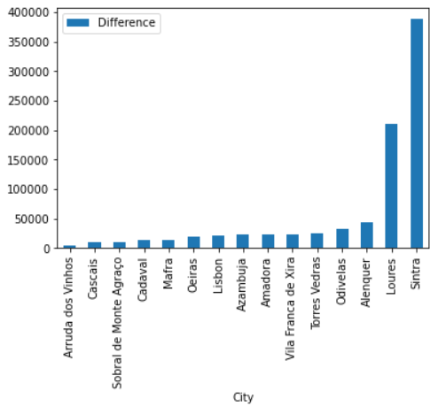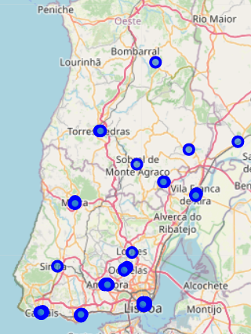

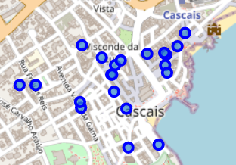 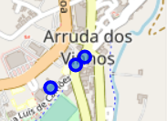

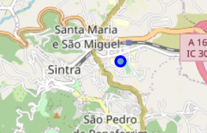 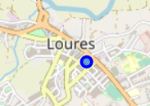

#### Best number of clusters

To define the best number of clusters, was used the Elbow Method. In a range of 1 to 15 clusters, the 9 seems the best number, as the plot line starts to get linear.

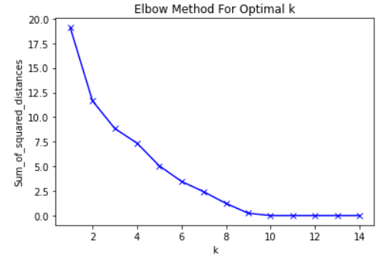

#### Clustering into cuisine groups

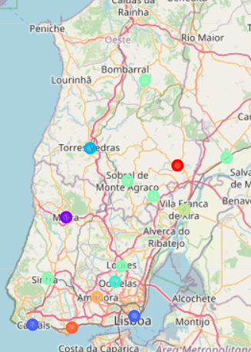

##### Cluster 1

The first cluster centers itself in Lisbon, with a lot of cuisine variety. It has no lack or excess of restaurants, which seems fair since it is the main tourism focus.



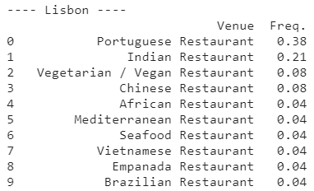 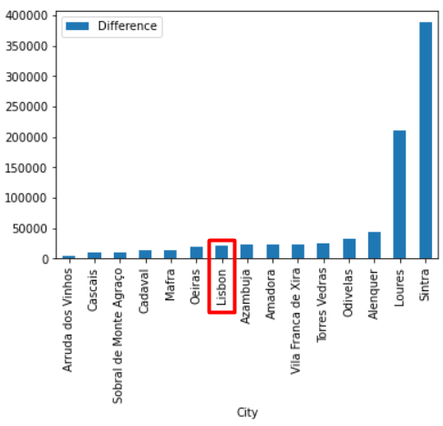

##### Cluster 2

The second cluster isolates itself with Modern European cuisine, a lack of variety and restaurants.



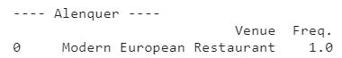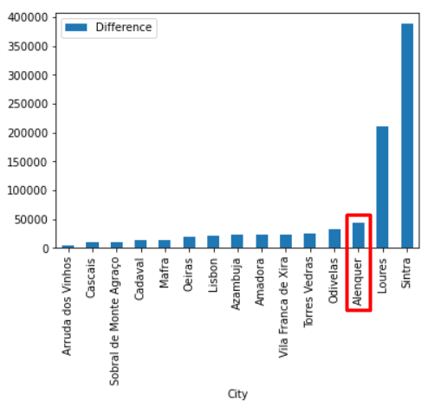

##### Cluster 3

The third cluster has a bit more of a variety compared to the last one and like Lisbon has no excess or lack of restaurants.





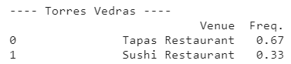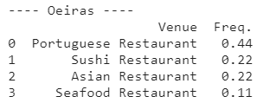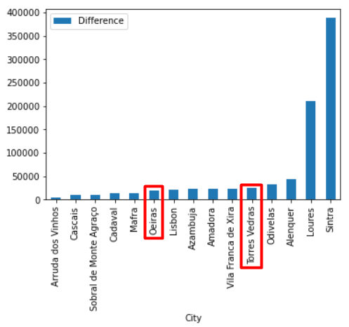

##### Fourth cluster

Focus itself in Portuguese cuisine and has no lack or excess of restaurants



 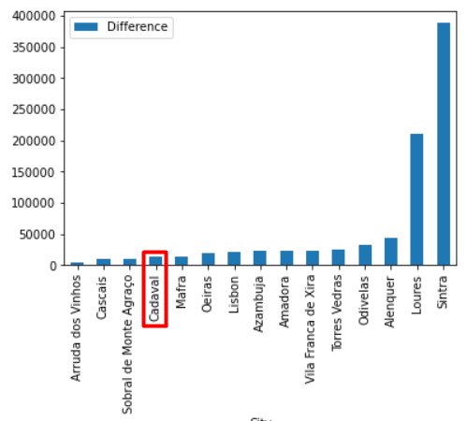

##### Fifth cluster

This cluster is very similar to Lisbon, has it contains a fair amount of variety but has an excess of restaurants.



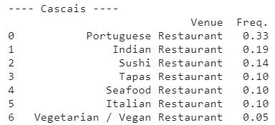 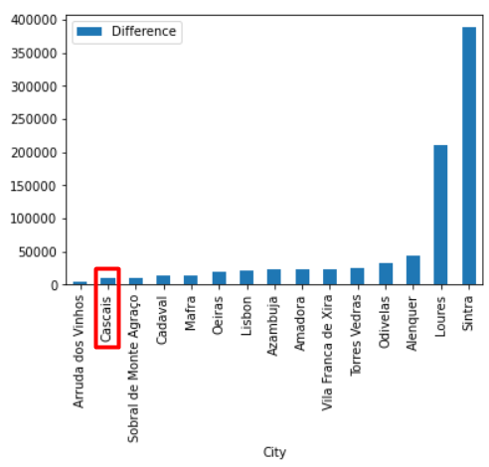

##### Sixth Cluster

The counties grouped here have a close taste in cuisine types (portuguese and sushi) and lack of variety. Sintra leads with the most lack of restaurants. On the other hand Arruda dos Vinhos leads with the most excess of restaurants.













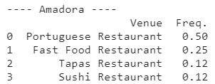

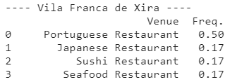





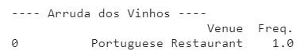

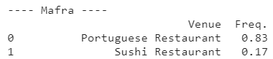 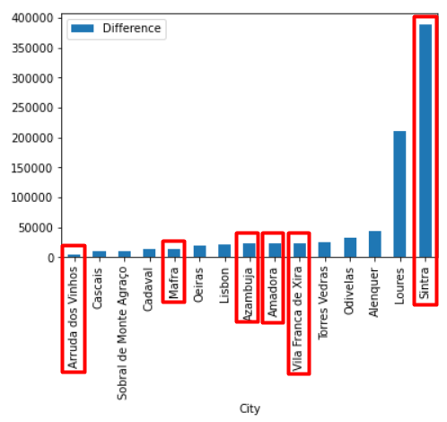

##### Seventh cluster

This one focus on portuguese cuisine and has the most lack of restaurants after Sintra.





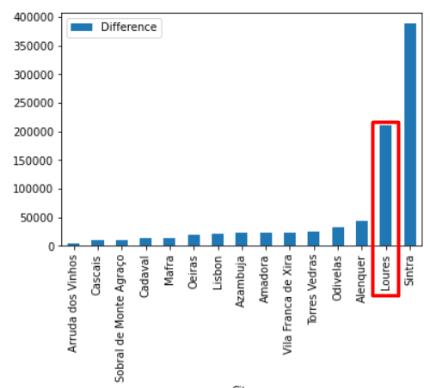

##### Eighth cluster

Similarly to the fourth cluster, focus on portuguese cuisine and has no lack or excess of restaurants.

##### Nineth

Similarly to the fifth cluster, has Italian cuisine. Has a little of variety and even though it does not lack as much as Sintra, it still lacks a bit of restaurants.



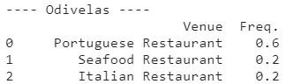 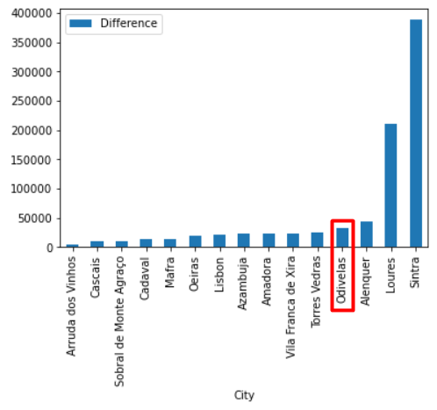

## Conclusion

* Lisbon and Cascais have the most variety of cuisines, which is normal as the main tourism focus lays in the center of Lisbon.
* On the other hand, Alenquer, Arruda dos Vinhos, Azambuja, Cadaval, Loures, Sintra and Sobral de Monte Agraço have the least variety.
* The most common restaurants are Portuguese and Sushi restaurants, and the least common are African and Mediterranean restaurants.
* Sintra and Loures have the most lack of restaurants and Arruda dos Vinhos and Cascais have the biggest number of venues.
* If you plan on opening a Portuguese cuisine restaurant, you will have lots of competition. If you don’t want competition, you can open up in Alenquer or Torres Vedras.
* If you plan on opening another type of cuisine, and have no competition, the best places would be Arruda dos Vinhos, Azambuja, Cadaval, Loures, Sintra and Sobral de Monte Agraço.
* If competition is not a problem, the best places are Lisbon and Cascais, which have a lot of tourism focus and you can open up almost any variety you want.
* The best cuisine types to open up are Portuguese, Sushi, Modern European, Tapas and Seafood.
* Of course this decisions are completely up to the person who will open a new restaurant business. The main idea is to give some insights of what would suit best for the desired restaurant business.